Assessment Schedule – 2012

Music: Demonstrate understanding of two substantial contrasting music works (91277)

Evidence Statement
Note: The requirement in questions One and Three to include evidence from or reference to the score must be treated in light of the fact that the candidate is not permitted to bring musical scores into the examination; all musical evidence presented in the answer to each question must be assessed holistically.

Question One
(see Appendix for sample responses)
 | N1 | N2 | A3 | A4 | M5 | M6 | E7 | E8
 | Identifies and attempts to describe the structure of the work, and / or attempts to describe a musical feature of the work. |  | Identifies and briefly describes the structure of the work, and / or describes a musical feature of the work, with some evidence from the score. |  | Identifies and describes in depth the structure of the work, and explains the use of an important musical feature of the work, with specific reference to the score. |  | Identifies and comprehensively describes the structure of the work, and insightfully explains the use of an important musical feature in the work as a whole, with perceptive reference to the score.
(a) | Attempts to describe and / or draw a diagram of the structure of the work | Attempts to describe and / or draw a diagram of the structure of the work | Briefly describes and / or draws a diagram of the structure of the work | Briefly describes and / or draws a diagram of the structure of the work | Describes in depth and / or draws a detailed diagram of the structure of the work | Describes in depth and / or draws a detailed diagram of the structure of the work | Comprehensively describes and / or draws a detailed diagram of the structure of the work, supported by precise musical evidence from the score | Comprehensively describes and / or draws a detailed diagram of the structure of the work, supported by precise musical evidence from the score
(b) | OR  Attempts to describe ONE feature of the work. | AND  Attempts to describe ONE feature of the work. | OR  Simply describes ONE feature of the work, supported by simple musical evidence. | AND  Simply describes ONE feature of the work, supported by simple musical evidence. | AND  Explains how ONE important feature is used in the music, supported by specific musical evidence. | AND  Explains how TWO important features are used in the music, supported by specific musical evidence. | AND  Explains the effect of the use of ONE important feature in the work as a whole, supported by perceptive musical evidence. | AND  Explains the effect of the use of TWO important features in the work as a whole, supported by a range of perceptive musical evidence.
N0= No response; no relevant evidence.

Question Two
(see Appendix for sample responses)
 | N1 | N2 | A3 | A4 | M5 | M6 | E7 | E8
 | Attempts to describe the circumstances of the creation and / or first performance of the work, and / or identifies features of the work that are characteristic of the genre / style / period. |  | Briefly describes the circumstances of the creation and / or first performance of the work, and identifies and discusses features of the work that are characteristic of the genre / style / period. |  | Describes in depth the circumstances of the creation and / or first performance of the work, and / or identifies and discusses in depth features of the work that are characteristic of the genre / style / period, and / or describes an aspect of the music that would need to be considered in a performance of the work as the composer / original performer intended. |  | Comprehensively describes the context in which the work was created and first performed, and identifies and comprehensively discusses features of the work that are characteristic of the genre / style / period, and insightfully explains an aspect of the music that would need to be considered in a performance of the work as the composer / original performer intended.
(a) | Attempts to describe the circumstances of the creation and / or first performance of the work | Attempts to describe the circumstances of the creation and / or first performance of the work | Briefly describes the circumstances of the creation and / or first performance of the work | Briefly describes the circumstances of the creation and / or first performance of the work | Describes in depth the circumstances of the creation and / or first performance of the work | Describes in depth the circumstances of the creation and / or first performance of the work | Comprehensively describes the historical context in which the work was created and first performed | Comprehensively describes the historical context in which the work was created and first performed
(b) | OR  Identifies TWO features of the work that are characteristic of the genre / style / period. | AND  Identifies TWO features of the work that are characteristic of the genre / style / period. | OR  Identifies TWO features of the work that are characteristic of the genre / style / period, AND discusses ONE feature, supported by simple evidence. | AND  Identifies THREE features of the work that are characteristic of the genre / style / period, AND discusses in depth ONE feature, supported by simple evidence. | AND EITHER  Identifies THREE features of the work that are characteristic of the genre / style / period, AND discusses in depth ONE feature, supported by specific evidence | AND  Identifies THREE features of the work that are characteristic of the genre / style / period, AND discusses in depth ONE feature, supported by specific evidence | AND  Identifies THREE features of the work that are characteristic of the genre / style / period, AND comprehensively discusses ONE feature, supported by perceptive evidence | AND  Identifies THREE features of the work that are characteristic of the genre / style / period, AND comprehensively discusses ONE feature, supported by a range of perceptive evidence
(c) |  |  |  |  | OR  Describes an aspect of the music that would need to be considered in a performance of the work as the composer / original performer intended. | AND  Describes an aspect of the music that would need to be considered in a performance of the work as the composer / original performer intended. | AND  Explains an aspect of the music that would need to be considered in a performance of the work as the composer / original performer intended, supported by perceptive evidence. | AND  Explains an aspect of the music that would need to be considered in a performance of the work as the composer / original performer intended, supported by perceptive evidence.
N0= No response; no relevant evidence.

Question Three
(see Appendix for sample responses)
 | N1 | N2 | A3 | A4 | M5 | M6 | E7 | E8
 | Attempts to describe compositional devices and / or performance techniques used in each work. |  | Identifies and briefly describes compositional devices and / or performance techniques used in each work, with some evidence. |  | Identifies and describes a range of compositional devices and performance techniques used in each work, with specific evidence. |  | Identifies and describes a range of compositional devices and performance techniques used in each work, and insightfully explains a similarity or difference in the use of one device / technique in both works, with perceptive evidence.
(a) | Attempts to describe a compositional device OR performance technique. | Attempts to describe ONE compositional device AND ONE performance technique. | For each work, identifies and briefly describes ONE compositional device OR ONE performance technique, supported by simple evidence. | For each work, identifies and briefly describes ONE compositional device AND ONE performance technique, supported by simple evidence. | Identifies and describes THREE compositional devices and / or performance techniques used in the works, supported by specific evidence. | Identifies and describes FOUR compositional devices and / or performance techniques used in the works, supported by specific evidence. | Identifies and comprehensively describes THREE compositional devices and /or performance techniques used in the works, supported by specific evidence | Identifies and comprehensively describes FOUR compositional devices and / or performance techniques used in the works, supported by specific evidence
(b) |  |  |  |  |  |  | AND  Explains a similarity or difference in the way ONE comparable feature is used in EACH of the works, supported by perceptive evidence. | AND  Explains a similarity or difference in the way ONE comparable feature is used in EACH of the works, supported by perceptive evidence.
N0= No response; no relevant evidence.

Judgement Statement
 | Not Achieved | Achievement | Achievement  with Merit | Achievement  with Excellence
Score range | 0 – 8 | 9 – 13 | 14 – 19 | 20 – 24

Appendix: Sample responses
Question | Achievement | Achievement with Merit | Achievement with Excellence
ONE | Work: “Muskrat Ramble”  Composer: Louis Armstrong and Edward “Kid” Ory  Genre / Style / Period: Dixieland Jazz
(a) | Brief description of the structure of the work | In-depth description of the structure of the work | Comprehensive description of the structure of the work
 | A, B, B, B, B, B, A, A, Tag | A, B, B, B, B, B, A, A, Tag | A, B, B, B, B, B, A, A, Tag
 |  | Melody instruments: Trumpet, trombone, clarinet | Melody section: Trumpet, trombone, clarinet (each instrument improvises)  Rhythm section: Banjo, guitar, piano, bass, drums (no improvisation; maintain the chord structure)
 | The work contains two main themes, each 8 bars long and repeated. The opening theme is stated in bar 1, by the trumpet. | The work contains two main themes, each 8 bars long and repeated. The opening theme is stated in bar 1, by the trumpet:  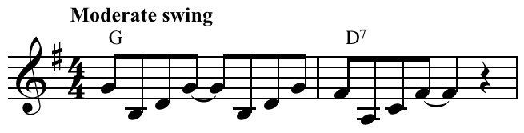 | The work contains two main themes, each 8 bars long (repeated). The trumpet in bar 1 states Theme A:  The clarinet and trombone reinforce the rhythm and chord structure with some improvisation.
 | The trumpet also states Theme B in bar 17, after which trumpet, trombone and clarinet improvise. | The trumpet also states Theme B in bar 17, after which each melody instrument in turn (trumpet, trombone and clarinet) improvises a melody based on the theme’s harmony. | Theme B is also stated by the trumpet, accompanied by some improvisation by the trombone (a descending scale in the first 2 bars)  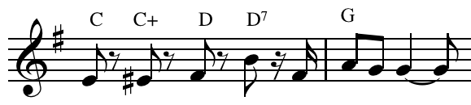  Each melody instrument in turn, then improvises Theme B, over the same chord progression played by the rhythm section.
 | When the opening theme returns, the trumpet, trombone and clarinet are all improvising together. It is repeated with different improvisations. | When the opening theme returns, the trumpet, trombone and clarinet are all improvising together. It is repeated with different simultaneous improvisations. | When Theme A returns, the trumpet, trombone and clarinet all improvise together over the original chord structure played by the rhythm section. This theme is then repeated with different simultaneous improvisations.
 | The music ends with a 2-bar tag. | The music ends with a 2-bar tag (or coda). | The music ends with a 2-bar tag (or coda) led by the trombone.
Question One cont’d
Question | Achievement | Achievement with Merit | Achievement with Excellence
(b) | Simple description of TWO features of the work, with simple musical evidence | Explanation of the use of TWO features of the work, with specific musical evidence | Insightful explanation of the use of TWO features, evaluating their effect within the work as a whole, with perceptive musical evidence
 | Element (1): Rhythm  The rhythm is swung (eg the opening theme is written out in quavers, but each two quavers are played as the first and last notes of a triplet). | Element (1): Rhythm  The rhythm is swung. The opening theme is written out in quavers:  However, when the melody is played, the quavers become triplets and the rhythm would sound:  Å˜= †Œ‰ | Element (1): Rhythm  The rhythm is mostly swung. The opening theme is written out in quavers (see music example in previous section). However, when the melody is played, the quavers become triplets and sound:  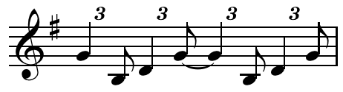  The opening two bars of Theme B, including the trombone’s scalic improvisation are played straight instead of being swung. In subsequent improvisations on both themes, the rhythm is swung.
 |  | Swung rhythm defines the music as jazz. | Swung rhythm defines the music as jazz. Dixieland is an early jazz and was developed by the now-freed slaves. It still reflected in many ways the polyrhythms of Africa.
 | Element (2): Texture  The opening texture is homophonic. The trumpet plays the melody over chords played by the rhythm section. | Element (2): Texture  The opening texture is homophonic. The trumpet plays the melody over chords played by the rhythm section. | Element (2): Texture  The opening texture is homophonic. The trumpet plays the melody over chords played by the rhythm section.  The texture changes to polyphonic at the beginning of Theme B when the trumpet and trombone parts are rhythmically independent.  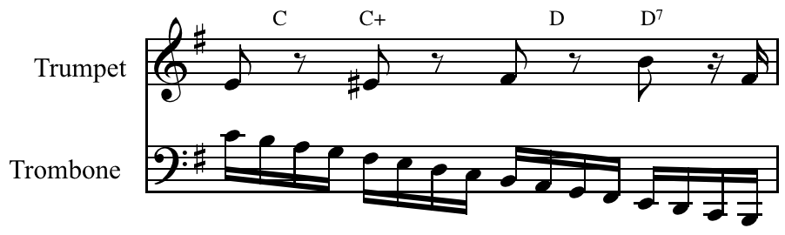
 | Later in the piece the texture becomes polyphonic – each instrument is rhythmically independent. | When Theme A returns, the texture becomes polyphonic – each melody instrument is rhythmically independent (but the rhythm section still maintains the same rhythm as at the beginning). | When Theme A returns, the texture becomes more obviously polyphonic with each melody instrument being rhythmically independent (but the rhythm section still maintains the same rhythm as at the beginning).
 |  | One of the main features of Dixieland is group improvisation – three soloists being rhythmically independent and producing a polyphonic texture. | As well as solo improvisation, Dixieland features group improvisation – three soloists being rhythmically independent and producing a polyphonic texture. With the advent of big bands, group improvisations, with their contrapuntal texture, were uncommon.

Question | Achievement | Achievement with Merit | Achievement with Excellence
TWO | Work: Messiah  Composer: G. F. Handel  Genre / Style / Period: Baroque
(a) | Brief description of the circumstances of the creation and / or first performance of the work | In-depth description of the circumstances of the creation and first performance of the work | Comprehensive description of the historical context in which the work was created and first performed
 | Messiah was written in the Baroque period for performance in a concert hall in Dublin in 1742. It was not Handel’s first oratorio, but it was so popular that he continued to write oratorios instead of operas. | Messiah was written in the Baroque period for performance in a concert hall in Dublin in 1742. It was not Handel’s first oratorio, but it was so popular that he continued to write oratorios instead of operas. | Messiah was written in the Baroque period for performance in a concert hall in Dublin in 1742. It was not Handel’s first oratorio, but it was so popular that he continued to write oratorios instead of operas. Handel began to write oratorios because his operas were no longer financially viable but the work, apart from having no costumes, action or scenery, is very similar to Handel’s operas.
 | Orchestra, choir, and soloists performed it. | Its original performance was by a small choir (about 25) with an orchestra that consisted mainly of strings with harpsichord and a few wind, brass and percussion instruments for colour (two each of oboes, bassoons, trumpets, and timpani). | Its original performance was by a small choir (about 25) with an orchestra that mainly consisted of strings with harpsichord and a few wind, brass and percussion instruments for colour (two each of oboes, bassoons, trumpets and timpani). In the choruses, an organ is added.
 |  | The performance also featured four vocal soloists. | The performance also featured four vocal soloists (soprano, contralto, tenor and bass) and like his operas, much of the music was composed to show off the vocal technique of each.

Question Two cont’d
Question | Achievement | Achievement with Merit | Achievement with Excellence
(b) | Identification of three features of the work that are characteristic of the genre / style / period, and discussion of one feature, with simple musical evidence | Identification of three features of the work that are characteristic of the genre / style / period, and in-depth discussion of one feature, with specific evidence | Identification of three features of the work that are characteristic of the genre / style / period, and comprehensive discussion of one feature, with perceptive evidence
(i) | Features, eg  - The orchestra is small and made up mostly of strings  - The instrumental accompaniment has a forward-moving bass line  - The work consists of choruses, recitatives and arias (see discussion)
(ii) | Discussion  A choir accompanied by orchestra performs the choruses, eg the “Hallelujah” chorus. | In-depth discussion  A choir accompanied by orchestra performs the choruses.  Choruses are accompanied by orchestra and have a variety of textures – monophonic (a single melodic line), homophonic (chordal), and polyphonic (rhythmically independent) eg the “Hallelujah” chorus. | Comprehensive discussion  A choir accompanied by orchestra with organ performs the choruses.  Choruses are accompanied by orchestra and have a variety of textures – monophonic (a single melodic line); homophonic (chordal), and polyphonic (rhythmically independent, eg the “Hallelujah” chorus, “Amen” chorus, “And the Glory of the Lord”).
 | Each chorus is preceded by a recitative and aria performed by one of the four soloists. | Recitatives tell the story and the words need to be heard, so the melody is not decorated eg “And there were shepherds abiding in the fields”. | Recitatives tell the story and the words need to be heard, so the melody is not decorated. There are two types of recitatives – recitativo secco (accompanied by harpsichord and cello) eg “And there were shepherds abiding in the fields”, and recitativo stromentato accompanied by strings eg “And lo, the angel of the Lord” (both for soprano). The melodic range in recitatives is quite limited.
 | Soloists perform the recitatives and arias that precede the choruses eg “And there were shepherds abiding in the fields” (recitative), “I know that my Redeemer liveth” (aria). | Arias comment on the story and often have decorated melodies to show off the technique of the soloist eg “I know that my Redeemer liveth”. | Arias comment on the story and often have decorated melodies to show off the technique of the soloist. An example is “Rejoice Greatly” for soprano. It contains much decoration on the word “rejoice” and has a far greater melodic range than the recitative that precedes it.
 |  | There are also some movements for orchestra alone eg the Pastoral Symphony. | There are also some movements for orchestra alone eg the Pastoral Symphony.
Question Two cont’d
Question | Achievement | Achievement with Merit | Achievement with Excellence
(c) |  | In-depth description of an aspect of the music that would need to be considered in a performance of the work as the composer / original performer intended, with specific evidence | Insightful explanation of how an aspect of the music would need to be considered in a performance of the work as the composer / original performer intended, with perceptive evidence
 |  | Trumpeters today are able to play the chromatic scale and to play in any key. In the Baroque period the trumpets did not have valves and could therefore play only the notes of the harmonic series. | Trumpeters today are able to play the chromatic scale and to play in any key. In the Baroque period the trumpets did not have valves and could therefore play only the notes of the harmonic series (see Ex 1 below).
 |  | It is only at the top of a trumpeter’s range that a melody could be played. | It is only at the top of a trumpeter’s range that a melody could be played. Many modern trumpeters would find it difficult to sustain performance in the high register of the trumpet.
 |  | The trumpet is used to give colour and excitement in some of the choruses (eg in the last section of the “Hallelujah” chorus, at the end of the sequential section “King of Kings”). | The trumpet is used to give colour and excitement in some of the choruses (eg in the last section of the “Hallelujah” chorus, at the end of the sequential section “King of Kings” – this is the climax of this chorus).  It is also an equal partner with the bass soloist in “The trumpet shall sound” and the introduction provides a good example of the use of the harmonic series (see Ex 2 below).
Ex 1:
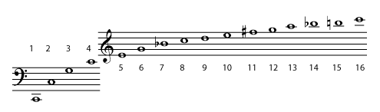
Ex 2:
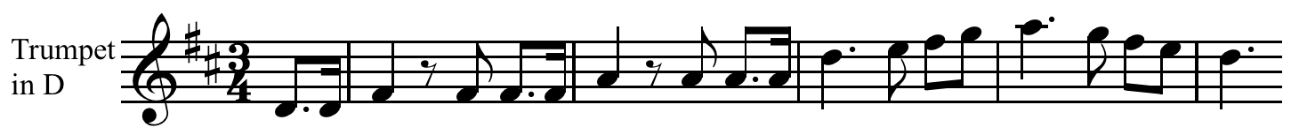

Question | Achievement | Achievement with Merit | Achievement with Excellence
THREE
(a) | Brief description of a compositional device and / or performance technique used in each work | Description of compositional devices and / or performance techniques used in each work | Comprehensive description of compositional devices and / or performance techniques used in each work
(i) | eg Syncopation in “Muskrat Ramble”
 | There is frequent use of syncopation throughout the music as is common in most jazz works. Syncopation is the accenting of a beat that is normally weak. In the first bar, a tie in the middle of the bar means the 3rd beat does not sound. | There is frequent use of syncopation throughout the music as is common in most jazz works. The example below shows syncopation by using a tie.  The fourth quaver is tied to the fifth, so the accent that would normally fall on the third beat occurs on the second half of the second beat. | There is frequent use of syncopation throughout the music as is common in most jazz works. The example below shows syncopation by using a tie.  The fourth quaver is tied to the fifth, so the accent that would normally fall on the third beat occurs on the second half of the second beat. Sometimes a rest is used on the beat to produce the same effect (eg the improvisations in Theme B).  Importantly, the rhythm section plays on the beat, so the syncopation is very obvious.
 | eg Sequence in Messiah
 | A sequence occurs when a motif is repeated at least twice more at a higher or lower pitch. An upward sequence occurs in the “Hallelujah” chorus at the words “King of Kings and Lord of Lords”. | A sequence occurs when a motif is repeated at least twice more at a higher or lower pitch. An upward sequence occurs in the “Hallelujah” chorus at the words “King of Kings and Lord of Lords” (see Ex 1 below). | A sequence occurs when a motif is repeated at least twice more at a higher or lower pitch. An upward sequence occurs in the “Hallelujah” chorus at the words “King of Kings and Lord of Lords” (see Ex 1 below). This is a melodic sequence. There is a slight variation in the rhythm because of the different words.  Sequences can be real (modulating) or tonal (melody only). This sequence is tonal (non-modulating).
 | Ex 1:

Question Three cont’d
Question | Achievement | Achievement with Merit | Achievement with Excellence
(a) (ii) | eg Improvisation in “Muskrat Ramble”
 | The main melodies are written out in full, but during the performance each soloist has an opportunity to improvise. The improvised part is based on the chords written above the melody line. | The main melodies are written out in full, but during the performance each soloist has an opportunity to improvise. The improvised part is based on the chords written above the melody line. The performer would add decorations and passing and auxiliary notes together with independent rhythms to improvise a part that is both melodically and rhythmically different from the original theme.
In Dixieland jazz, there are two types of improvisation:
- Solo improvisation, where a soloist improvises alone over the chords played by the rhythm section.
- Group improvisation, where more than one instrument improvises at the same time.
In Dixieland improvisation, each melody instrument has a specific role:
- The trumpet plays a “jazzed up” version of the original melody but introducing new rhythm (eg the first group improvisation of Theme A).
- The trombone often embellishes the bass line (eg in the first statement of Theme B), and also frequently uses smears and slides.
- The clarinet plays a highly embellished melody over the trumpet’s improvisation (eg the first group improvisation of Theme A).

Question Three cont’d
 | eg Figured bass in Messiah
 | The harpsichord part is not written out in full. Instead, the performer makes up her part from the figures underneath the string bass part. No figures indicate a root position chord. The figure 6 would indicate a first inversion chord. | The harpsichord part is not written out in full. Instead, the performer makes up (or realises) her part from the figures underneath the string bass part. No figures indicate a root position chord. The figure 6 indicates a first inversion chord; 7 indicates a 7th chord.  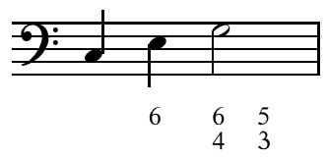  might be realised as  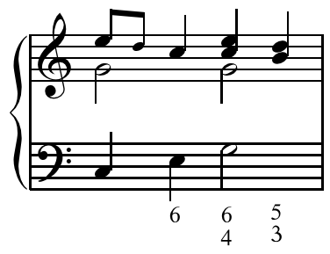  The presence of the small (passing) note would depend on whether other performers’ parts included a passing note. | The harpsichord player makes up (or realises) her part from the figures underneath the string bass part. No figures indicate a root position chord. The figure 6 would indicate a first inversion chord. The figures underneath indicate which chord should be played (eg 6 for a first inversion chord; 7 for a 7th chord). [Similar musical evidence included as for Merit].
The harpsichord player was able to complete the harmony if all instruments were not available, but mostly does not play a solo part. The time when the harpsichord part would be clearly heard is in a recitativo secco (eg “And there were shepherds abiding in the fields”). In such recitatives, only a single cello and the harpsichord accompany the singer.
At the end of a recitative, it is common for the cello and harpsichord to realise the final perfect cadence after the end of the vocal part even though the given figuring does not indicate this.

Question Three cont’d
Question | Achievement | Achievement with Merit | Achievement with Excellence
(b) |  |  | Explanation of a similarity and / or difference in the way a comparable feature is used in each work
eg Rhythm
Both genres have conventions in performance that are not obvious in the written score.
In jazz, quavers are usually swung. This is some-times indicated at the beginning of the score as
Å˜= †Œ‰
Sometimes, instead, swung quavers are notated

The performance of the music is exactly the same as before (ie triplets) – the dotted note is slightly shortened and performed as
†Œ‰
In Baroque music notated as the dotted quaver is doubly dotted in performance to 
In “The trumpet shall sound”, the opening trumpet part is written as in Ex 1 below, but would be performed as in Ex 2.
Ex 1: As written
Ex 2: As performed

